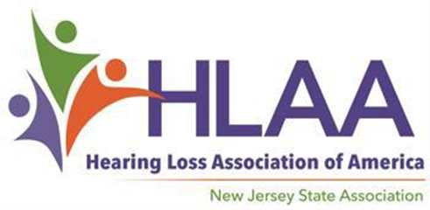

2024 Scholarship Award Program

For High School Seniors with Hearing Loss

You are encouraged to apply if…

Scholarship Applications Available at Hearingloss-nj.org

An Application consists of a Form,
Letters of Reference….
and an Essay — Get started now!

Submission Deadline

April 1, 2024

For more information, visit HLAA- NJ website:

Hearingloss-nj.org

Questions? Contact
Porter-Vaughn, Scholarship Chair Latisha.Porter-Vaughn@hearingloss-nj.org
Miatalking2002@gmail.com
♦ You are a high school senior
with hearing loss…

♦ You are a New Jersey resident,
17-20 years old…

♦ You plan to continue your education in Fall 2024...

♦ You are ambitious and determined not to let hearing loss get in the way of
your dreams!

2 Scholarships @ $1,000 each on behalf of The Hearing Society established in 1931.

Winners will be honored in May at our Scholarship Social. Location, date and time to follow.
*Many thanks to funds raised at the annual HLAA Walk4Hearing, held on October 2023 in West Windsor, NJ.

